**Healthy Weight FHIR Suite**

**Analytics & Reporting Module**

**Team-Too**

**(Daniel Hegberg, David Stevens, David Baily, Kirk Pastorian)**

**User Guide Version 1.1**

**4-28-16**

**NOTE regarding operability and usage:**

1. The Analytics & Reporting module is an integrated component of the Healthy Weight FHIR Suite developed for the Center for Disease Control (CDC). The current version of the Analytics & Reporting module is NOT intended for standalone operation and functionality will be limited if run in the absence of other Healthy Weight FHIR Suite components.
2. The Analytics & Reporting module is designed to operate with a suitably configured HL7 FHIR server. The Analytics & Reporting module must be configured with the appropriate connectivity details to access the HL7 FHIR server prior to running the application.
3. Data visualizations and graphs are presented in a preconfigured manner web-application and require a javascript-capable browser.
4. Functional descriptions and usage requirements for other Healthy Weight FHIR Suite components are not provided in this document and may be obtained by referencing the appropriate module user guide / instructions.

**Healthy Weight FHIR Suite Introduction**

The Healthy Weight FHIR Suite, comprises four integrated applications designed to help understand and reduce the prevalence of childhood obesity. The Suite includes patient-facing, provider-facing, care manager, and analytic & reporting functions that leverage HL7 FHIR and SMART-on-FHIR capabilities. Data management and exchange conforms to health industry standards (HL7/IHE) and can be made compatible with existing FHIR servers. The Healthy Weight FHIR Suite is also compatible with a wide array of portable and internet-connected devices enabled as a web-application for maximum flexibility.

The focus of the analytics & reporting components of the Suite provide:

* Automatic determination of Body Mass Index (BMI)
* Individualized screening for obesity risk
* Statistical analysis of weight data based on known population distributions
* Convenient data collection and reporting mechanisms
* Data access to entities interested in evaluating body weight information at the population level (for example Medicare, public health and community / practice groups)
* Mapping key healthy weight data elements to existing FHIR resources
* Visualizations for interpreting data and information in an accessible manner

Convenient user-reported data entry is available from other Suite components and leveraged by the Analytics & Reporting module for storing and calculating care quality metrics (e.g. BMI Percentiles) that facilitate individual clinical decision making. Healthy weight and performance tracking is provided using quality indicators, allowing physicians to identify metrics such as percent of patients in a practice that are overweight or obese. The Analytics & Reporting module further leverages the additional functionalities and resources implemented in other Suite components for capturing quality weight & behavior data that can be pushed into EHRs. Together the modules of the Suite provide an open & extensible architecture with data extraction capabilities to support research, evaluation, and surveillance of individual health data (both in identified and de-identified manners).

**Healthy Weight FHIR Suite Connectivity**

1. Data access and interconnectivity between the various modules requires access to the same HL7 FHIR Server. The default FHIR server used by the Suite resides at:

**GT FHIR SERVER: http://polaris.i3l.gatech.edu:8080/gt-fhir-webapp/base/**

This server is a Java HAPI-FHIR (version 1.4) that provides open-access to appropriately configured HAPI-FHIR clients (hapi-fhir-cli) allowing access to server content and web pages.

1. The Analytics & Reporting module is invoked by other components of the Healthy Weight FHIR Suite through parameter passing. The default parameter string should be provided in the exemplary general format:

[**http://cdc-obesity-dashboard.azurewebsites.net/#/ID#**](http://cdc-obesity-dashboard.azurewebsites.net/#/ID)

**The first # is required.**

**The ID# represents a selected practice number**

**(use -1 for all data and numbers 1-5 for pre-configured test practices)**

When the Analytics & Reporting module receives a parameter string, it will parse the string and generate output corresponding to pre-selected analytics and graphics. This information may be accessed by directing a web-browser to the URL below:

**http://cdc-obesity-dashboard.azurewebsites.net/#**

Various functionalities for manipulating data ranges, graphical formats, and other aspects of the output report are provided in the web-application and are described in greater detail in other portions of this document and in the accompanying demo video (see Final Project Deliverable PowerPoint Presentation).

**Report View and Interpretation**

The Analytics & Reporting module leverages data collected from the patient-facing application of the Suite that has been stored within electronic medical records maintained in the FHIR database. For each subject in the database, Body Mass Index (BMI) calculations are performed dividing the subject weight (in kilograms) by the subject height squared (in meters). BMI represents an important metric to evaluate whether an individual is within a healthy weight range based on age and other factors.

Exemplary screenshots taken from the Analytics & Reporting web-app are shown below.

Practice Selection



Using the ID# identified by the input parameters **a selected practice number is indicated.**

**(in this case -1 for all practices)**

Figure 1: Data Filtering

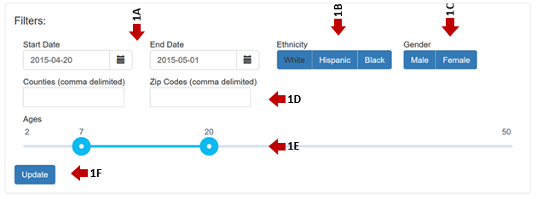

The web-app provides the ability to select, group, and chart data stored in the FHIR database. Date ranges (1A) may be specified in the provided fields to determine specific data displayed in subsequent graphs.

Population-level grouping and analysis is facilitated by additional buttons for selecting subjects by ethnicity (1B), gender (1C) census tract including County and Zip Code (1D), and age (1E).

After configuring and selecting desired data parameters, use the “Update” button (1F) to perform calculations and update the presented data.

Figure 2a: Charting

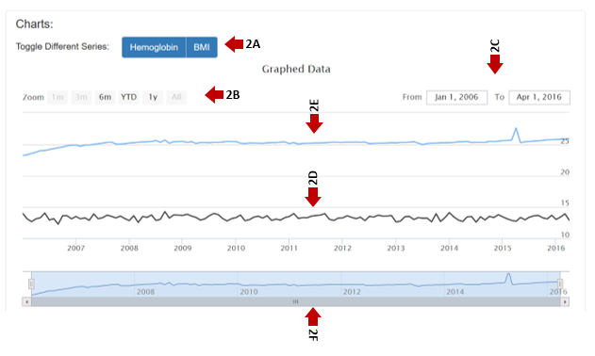

Selections specified in the data filtering section are presented in a pre-configured graphical format as shown in Figure 2. BMI calculations are selectable using the series buttons (2A) along with associated hemoglobin a1c values (if present within the FHIR database).

BMI trends (2D) are shown for the selected date range (2C) and may be overlaid with hemoglobin values (2E) for the corresponding data set.

The formatting and scale of the chart may be selected according to the “Zoom” buttons (2B) which set forth pre-defined ranges that are further highlighted in the data range graph (2F).

Figure 2b: Chart Details

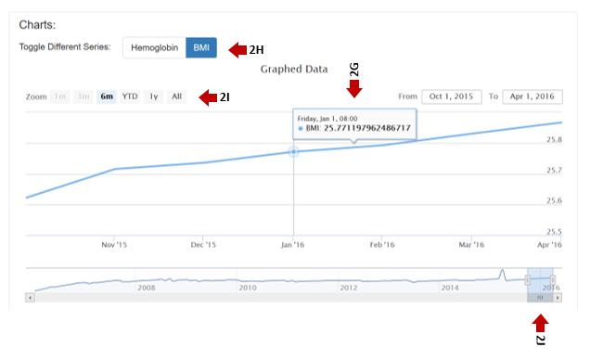

The Analytics & Reporting module leverages interactive graphing functionalities that allow the user to hover over specific data points and regions of each graph to obtain more detailed information.

In the exemplary dataset shown in Figure 2B, the calculated BMI (2G) for a selected point on the graph is shown. As discussed above, a user may select various types of data to be presented (2H) that is scaled on a desired interval (2I) and representing a subset of highlighted data (2J).

Figure 3: Population View

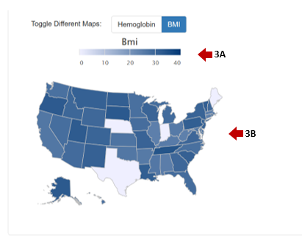

As shown in Figure 3, a population view is also provided for selected data. Using geographical information stored in the FHIR database along with details from specific subjects, BMI values may be presented by color shading (3A) and mapped to specific regions such as States (3B). This manner of data presentation provides a useful way to view aggregated data and trends, for example, to visualize populations level statistics for subjects classified as underweight, normal weight, overweight or obese (UW, NW, OW, OB). Subject classifications can further be compared to local, state or national estimates (state estimates from BRFSS, national from NHANES).

Figure 4: Risk Metrics

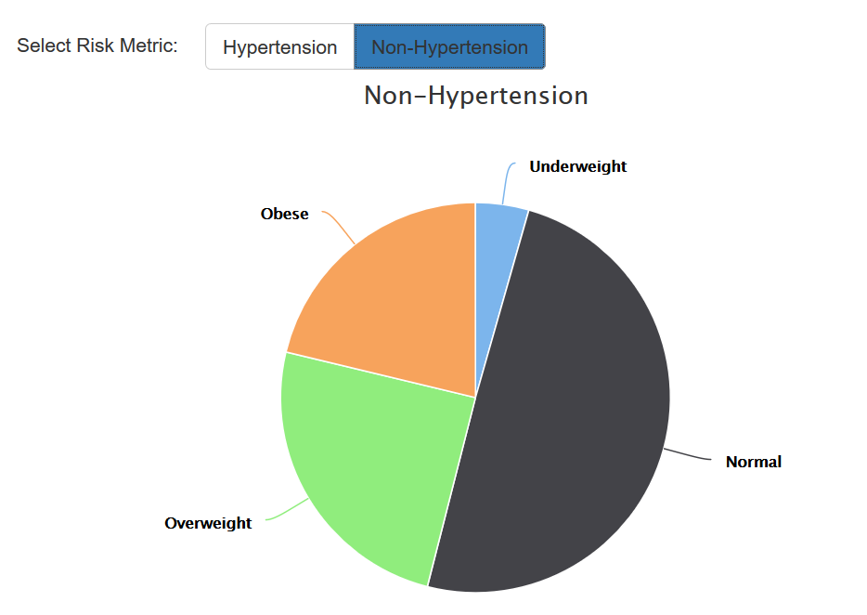

As shown in Figure 4, risk metric classifications and visualizations are provided for selected data. The current module provides functionality for evaluating hypertension risk in connection with existing BMI weight classifications.

Figure 5: Subject Data Detail View

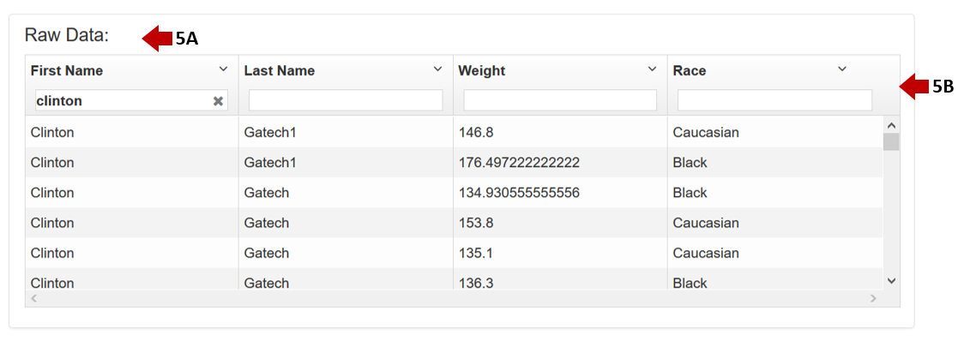

As shown in Figure 5, details (5A) stored in the EHR’s associated with individual subjects may be reviewed. Various selector fields (5B) may be populated to further restrict and group the data as desired. A subset of data fields are shown, additional fields are available during module execution.

**Analytics & Reporting Module**

**Requirements & Specifications**

User Requirements

1.1 Software Interfaces

Development environment -- Visual Studio 2015

ASP.NET Web Application

Development Module - Angular (Javascript / web-application framework)

(free version available)

Development Module - Highcharts

(free version available)

Database: SQL-lite for data persistence preconfigured and transparent to the user

(pre-installed w/ application)

Languages: C#, Javascript, JSON, JQuery

1.2 User Interfaces

Application functionality accessible via web browser

(Firefox, Internet Explorer, Opera, Safari, etc)

Connectivity to HL7 FHIR server preconfigured

1.3 User Characteristics

It is expected that many different types of users with varied experience levels will interact with the Suite.

Data entry should provide convenient collection mechanisms for use with mobile devices.

Visualization should be easy to understand even for users with limited medical knowledge (e.g. kids / young adults).

Potential End Users include:

-- Individual providers / Clinicians

(viewing patient panels)

-- Small groups of providers

(e.g., medical practices & clinic)

-- Healthcare entities

(e.g., Children’s Healthcare of Atlanta with multiple outpatient clinics and settings)

-- Healthcare payers

(e.g., private insurers or healthcare providers)

1.4 Assumptions / Limitations

Users will have access to a web browser capable of running web-applications, Javascript, and stable internet connectivity.

Supported platforms include: PC/Windows, MAC/OSX, Phones & Tablets / IOS , Android

Users have basic familiarity with the operation of selected device and establishing network connectivity

Personal information may be saved and retrievable in identified and de-identified forms (dependent on mode of access)

System Requirements

2.1 Functional Requirements

2.1.1 Actions

Display Subject data fields (Subject Name, Age, Weight)

Select Subject for visualization

Calculate Body Mass Index

Display Body Mass Index

Display Subject Characteristics (Height / Weight)

Select Display Range

2.1.2 Data Collection / Availability

Data collected from the patient-facing application will be stored in a selected Subject's electronic medical record maintained in the FHIR database

Collected data will be used to calculate Body Mass Index information

Additional data including Subject height and weight will be accessible to other applications of the Suite

Data maintained in the FHIR database will be made accessible to other Suite applications

Data will be available to break down and group by age group, race/ethnicity, gender and census tract

Records will include information as set forth in the classes set forth below (Section 2.1.5)

Biometrics:

-- Percentage of Subjects in practice/group classified as underweight, normal weight, overweight or obese (UW, NW, OW, OB)

-- Percentage of Subjects in practice/group that report particular behaviors, by frequency of that behavior

-- Trends over time of percentage of Subjects classified as overweight or obese (for that practice/group)

-- Comparison of percentage of Subjects classified as UW/NW/OW/OB to local, state or national estimates (state estimates from BRFSS, national from NHANES)

-- Percentage of Subjects with hypertension (based on administrative code for hypertension)

-- Subject hemoglobin a1c (%)

2.1.3 FHIR Database Accessibility

The Reporting app provides analytical capabilities to process data contained in the FHIR database

The reporting app provides visualization & data mapping capabilities allowing subsets of data (e.g. individual Subject data) to be further processed

The reporting app is callable by the physician-facing app to provide Subject information, data & performance indicators

The reporting app provides capabilities to select percent of patients in a physician's practice (or other sub-group) that are overweight or obese (based on BMI calculation)

The reporting app provides capabilities to determine percent of obese Subjects that receive counseling & referrals

The reporting app provides capabilities to determine what referrals are most effective

The reporting app is callable by the community-facing app to access similar quality measures as the physician-facing app

The reporting app provides capabilities to extract Subject data & information

Data provided by the reporting app will be de-identified based on the application

2.1.4 Mapping function:

Analytics are provided for identifying regional “hot spots” of elevated BMI

Analytics are provided for identifying reported poor behaviors (and ability to compare to other areas)

2.1.5 Classes & Variables:

----------

Patient / Type

-- ID / String

-- First Name / String

-- Last Name / String

-- Middle Name / String

-- Sex / String

-- Ethnicity / String

-- Insurance_Type / String

-- DOB / Date

-- Address / List<Address>

-- LabTest / List<Lab>

-- Current_Weight / Float

-- Current_Height / Float

-- Weights / List<Weight>

-- Heights / List<Height>

-- Counseling_Sessions / List<Counseling>

-- Children / List<Patient>

----------

Address / Type

-- Street / String

-- City / String

-- State / String

-- Zip / String

-- County / String

----------

Lab / Type

-- Lab_ID / String

-- Lab_Name / String

-- Date / Date

-- Results / List<String>

----------

Weight / Type

-- Date / Date

-- Measurement / Float

----------

Height / Type

-- Date / Date

-- Measurement /Float

----------

Counseling / Type

-- Date / Date

-- Counsel_Name / String

----------

Clinic / Type

-- Date / Date

-- Patient_ID / String